**Assignment 2**

| **Team ID** | PNT2022TMID14121 |
| --- | --- |
| **Project Name** | Inventory Management System for  Retailers |

**Question:**

1. **Create a User table with a user with email, username, roll number, password.**
2. **Perform UPDATE, DELETE Queries with user table**
3. **Connect python code to db2.**
4. **Create a flask app with registration page, login page and welcome page. By default, load the registration page once the user enters all the fields, store the data in the database and navigate to the login page to authenticate user username and password. If the user is valid, show the welcome page.**

**1.Create User table with user with email, username, roll number, password.**

**Solution:**

**CREATE TABLE USER(**

**USER_ID INT GENERATED BY DEFAULT AS IDENTITY NOT NULL,**

**EMAIL_ID VARCHAR(150) NOT NULL,**

**USER_NAME VARCHAR(255) NOT NULL,**

**ROLL_NUMBER VARCHAR(100) NOT NULL, PASSWORD VARCHAR(100) NOT NULL, PRIMARY KEY (USER_ID)**

**);**

**INSERT INTO USER(EMAIL_ID,**

**USER_NAME,ROLL_NUMBER,PASSWORD)**

**VALUES('rk9166771@gmail.com','Rajeshkumar**

**S','19CS123','9787234640');**

**INSERT INTO USER(EMAIL_ID,**

**USER_NAME,ROLL_NUMBER,PASSWORD) VALUES('ramachandramoorthykb@gmail.com','Ramachandramoorthy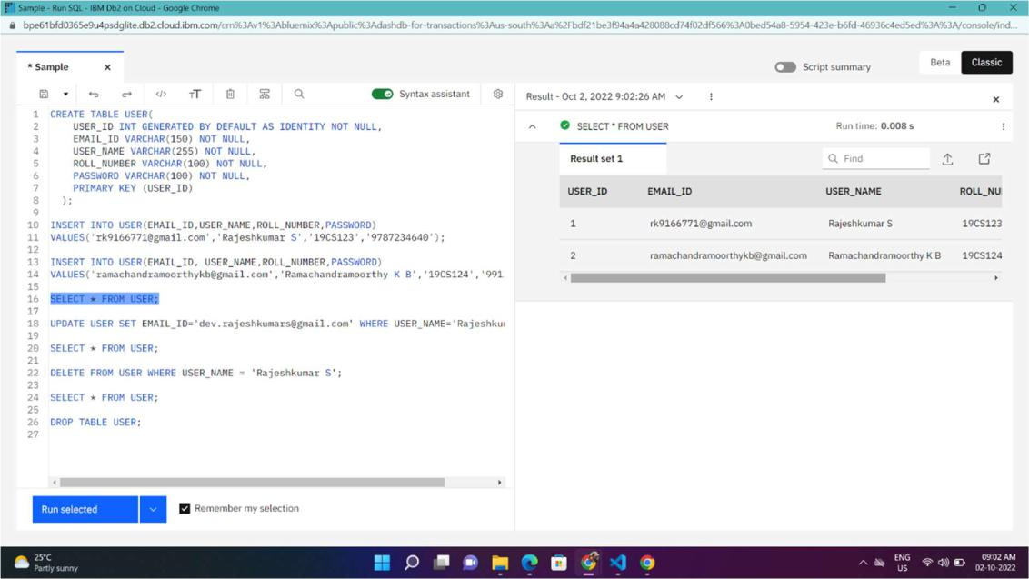K B','19CS124','9912346578')**

**2.Perform UPDATE, DELETE Queries with user table.**

**Solution:**

**UPDATE:**

**UPDATE USER SET EMAIL_ID='dev.rajeshkumars@gmail.com' WHERE USER_NAME='Rajeshkumar S';**

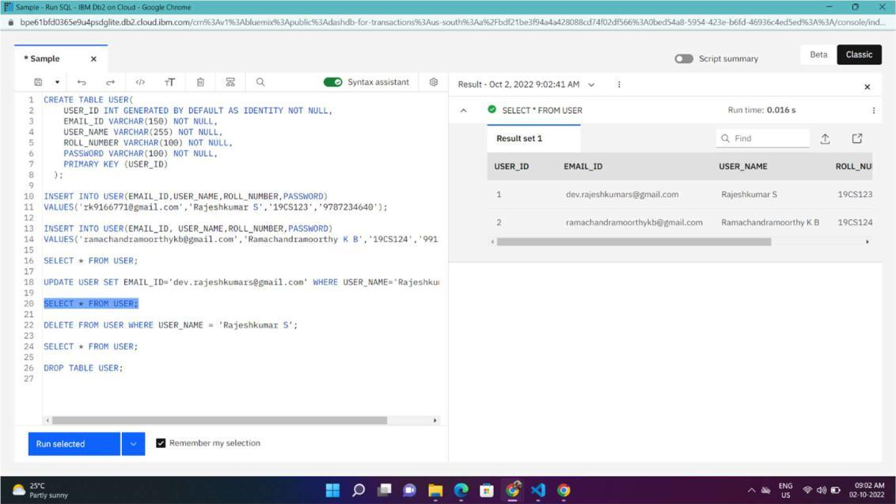

**DELETE:**

**DELETE FROM USER WHERE USER_NAME = 'Rajeshkumar S';**

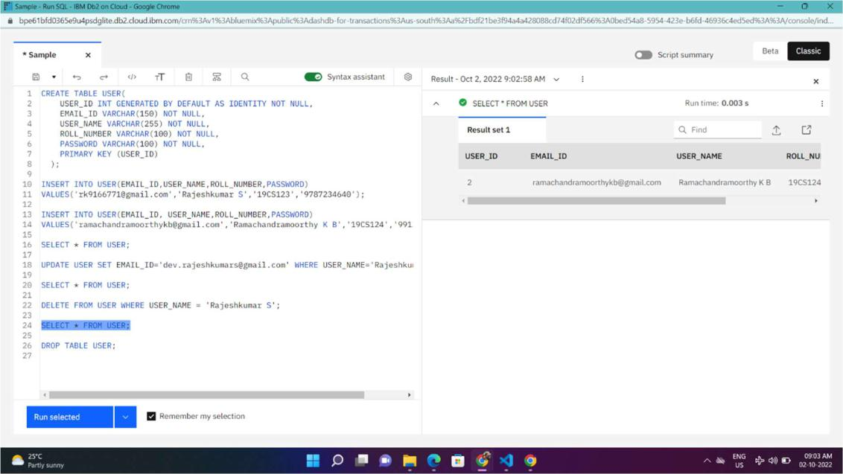

1. **Connect python code to db2. Solution:**

**def Connection():**

**try:**

**conn = ibm_db.connect("DATABASE=bludb;HOSTNAME=21fecfd8-47b7-**

**4937-840d-**

**d791d0218660.bs2io90l08kqb1od8lcg.databases.appdomain.cloud;PORT=31864;SE**

**CURITY=SSL;SSLServerCertificate=DigiCertGlobalRootCA.crt;UID=xjk42376;PW**

**D=liEWs4fS57ABi3h1", "", "")**

**print ("Database Connected Successfully !")**

**return conn**

**except:**

**print ("Unable to connect: ", ibm_db.conn_errormsg())**

1. **Create a flask app with registration page, login page and welcome page. By default, load the registration page once the user enters all the fields, store the data in the database and navigate to the login page to authenticate user username and password. If the user is valid, show the welcome page.**

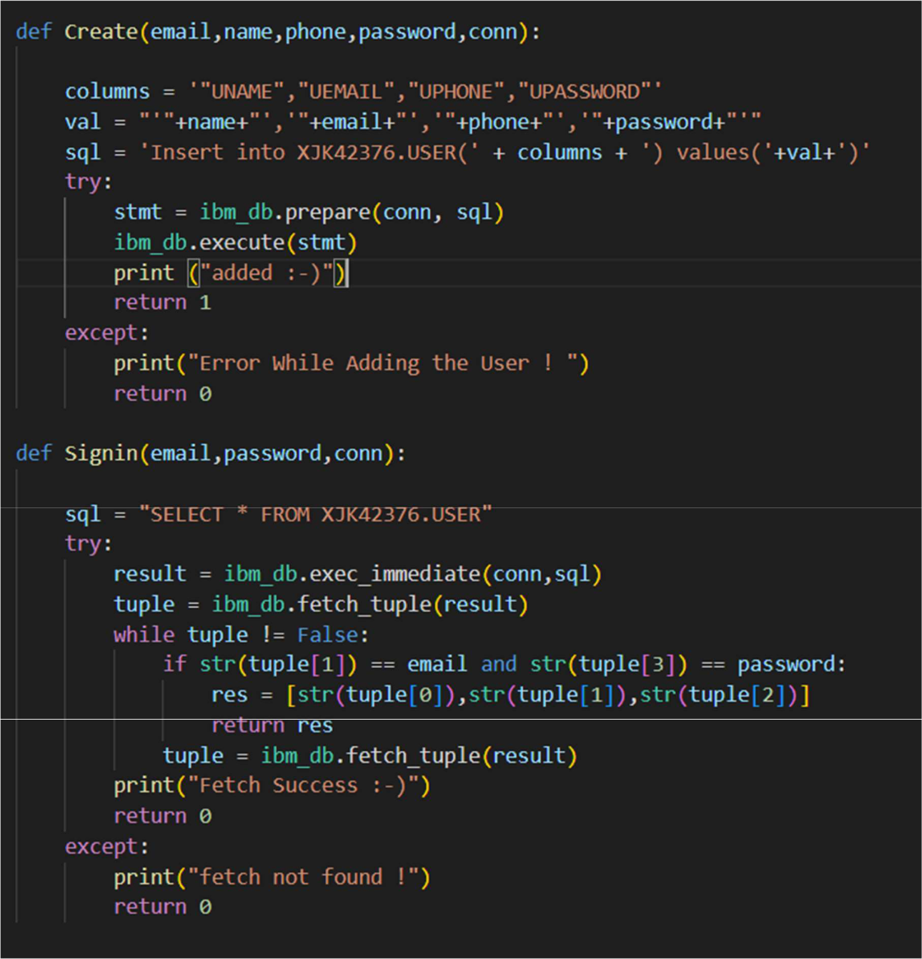

**Output**

**Signup Page:**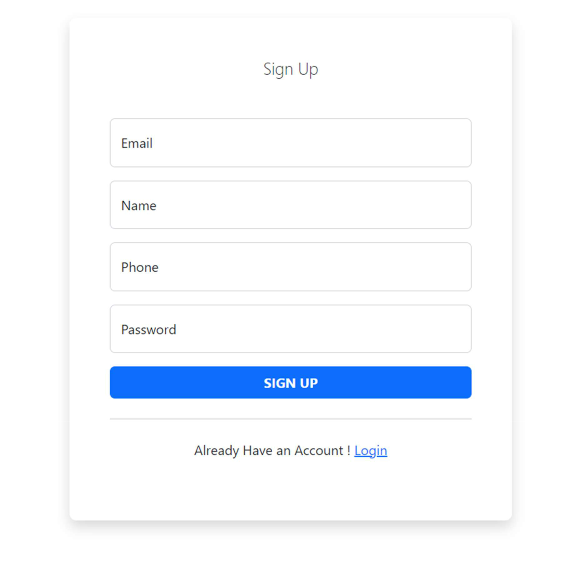

**Login Page:**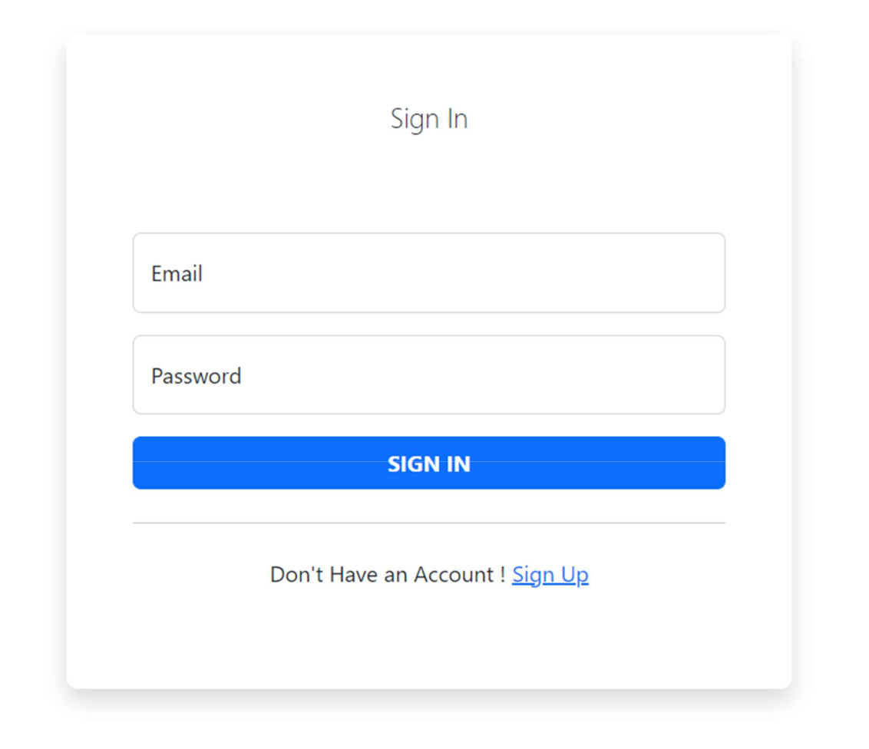

**When Email or password is Invalid:**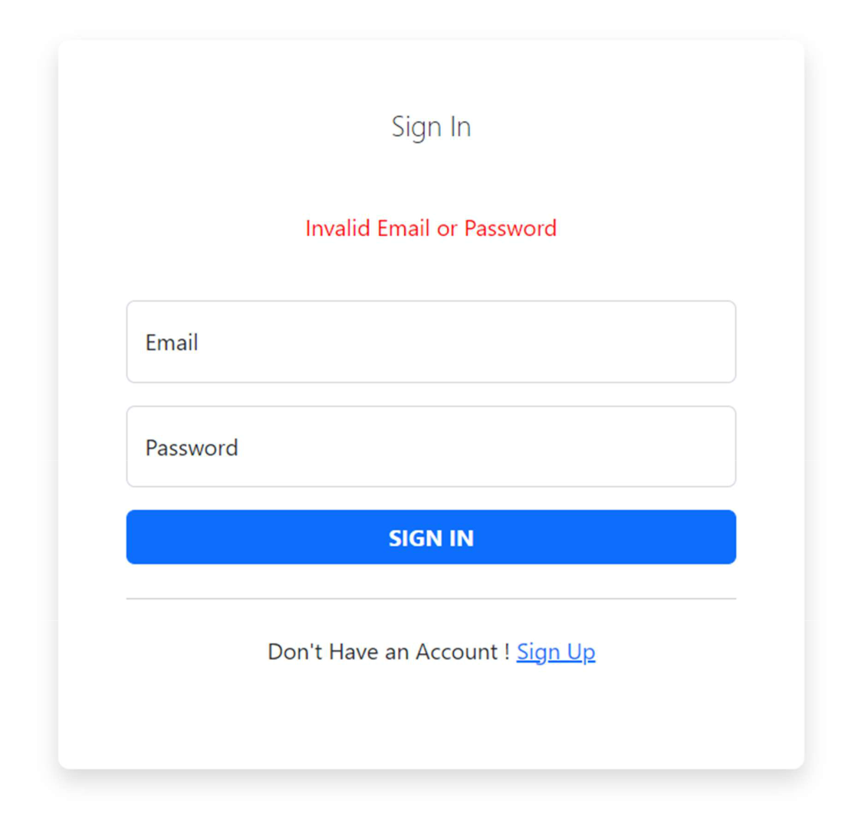

**Table**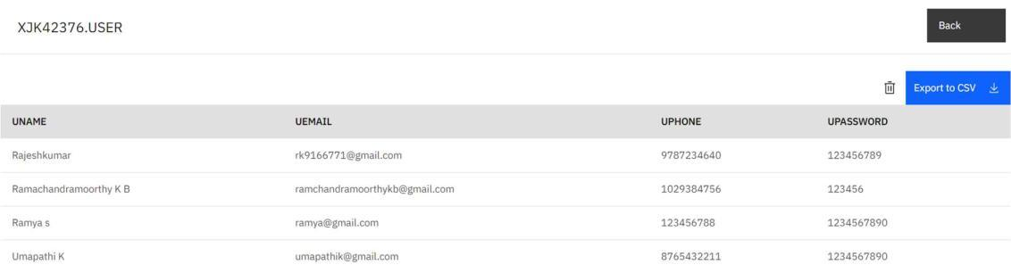

**Home Page**